CHILD ASSESSMENT FORM
In an effort to help your child adjust to our program and to serve you better, please take a few moments to answer the following questions. Thank you.
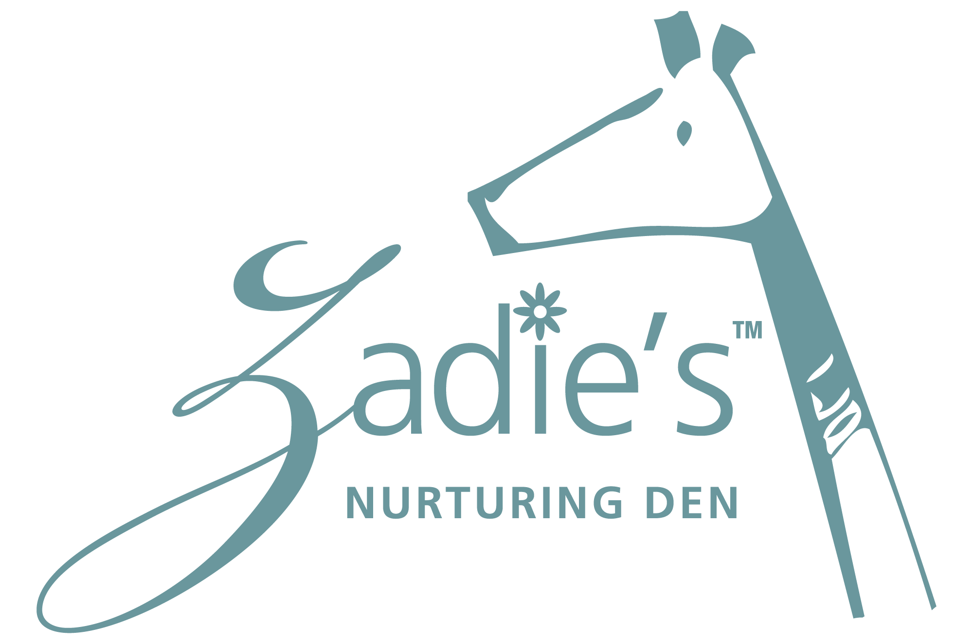

CHILD’S NAME: _____________________________________ | BIRTHDATE: ___________________________

- What is your child’s current daily sleeping schedule?

Morning: ____________________ | Afternoon: _____________________ | Evening: ______________________

- What upsets or frightens your child?

__________________________________________________________________________________________________

__________________________________________________________________________________________________

- What does your child find soothing or comfortable?

__________________________________________________________________________________________________

__________________________________________________________________________________________________

- Does your child have any known allergies?  Yes  No

If yes, please specify______________________________________________________________________________

- Does your child have any delays (speech, learning, etc.) that we should be aware of?  Yes  No

If yes, please specify_________________________________________________________________________

- Is your child currently in therapy?  Yes  No

If yes, please list the therapy and therapist.

__________________________________________________________________________________________________

__________________________________________________________________________________________________

- Have you spoken with your pediatrician about childhood obesity?

__________________________________________________________________________________________________

- Does your child suffer from any chronic illnesses?

__________________________________________________________________________________________________

INFANTS ONLY

- Are you breastfeeding your child?  Yes  No

- Is your child drinking...? (Check all that apply)
❒ Formula  Whole Milk  Skim Milk
❒ Other (Please list the name of the milk your child is consuming)_________________________________________
(Please note: Zadie’s™ is a nut free environment, please refrain from bringing in almond milk or any other milk derived from nuts.)

- Is your child using a...?  Cup  Bottle  Both

- Is your child eating...?  Baby Food  Table Food
(Please note: All formula must be prepared according to the manufacturer’s instructions. Bottle feedings do not contain solid foods unless the child’s health care provider supplies written instructions and a medical reason for this practice.)

- Do you have any feeding concerns for your child?  Yes  No
If yes, please specify________________________________________________________________________________

INFANTS, TODDLERS, PRESCHOOLERS, PRE-KINDERGARTENERS

- Has your child begun potty training?
_______________________________________________________________________________________________

- Does your child have any behavioral issues we should be aware of? (ie. hitting, kicking, biting) ?  Yes  No

If yes, please specify: _____________________________________________________________________________

- Has your child previously been in school or play groups?  Yes  No

If yes, please specify: _____________________________________________________________________________

- What form of discipline do you use at home?
_______________________________________________________________________________________________

- What academic skills has your child acquired? (ie. counting, recognizes letters, shapes, can write full name, etc. )

_______________________________________________________________________________________________

_______________________________________________________________________________________________

- Does your child have any special interests?

_______________________________________________________________________________________________

_______________________________________________________________________________________________

- Do you want to enroll your child in public or private school for Kindergarten?  Public  Private

