PARENT CONTRACT
Zadie’s™ Nurturing Den
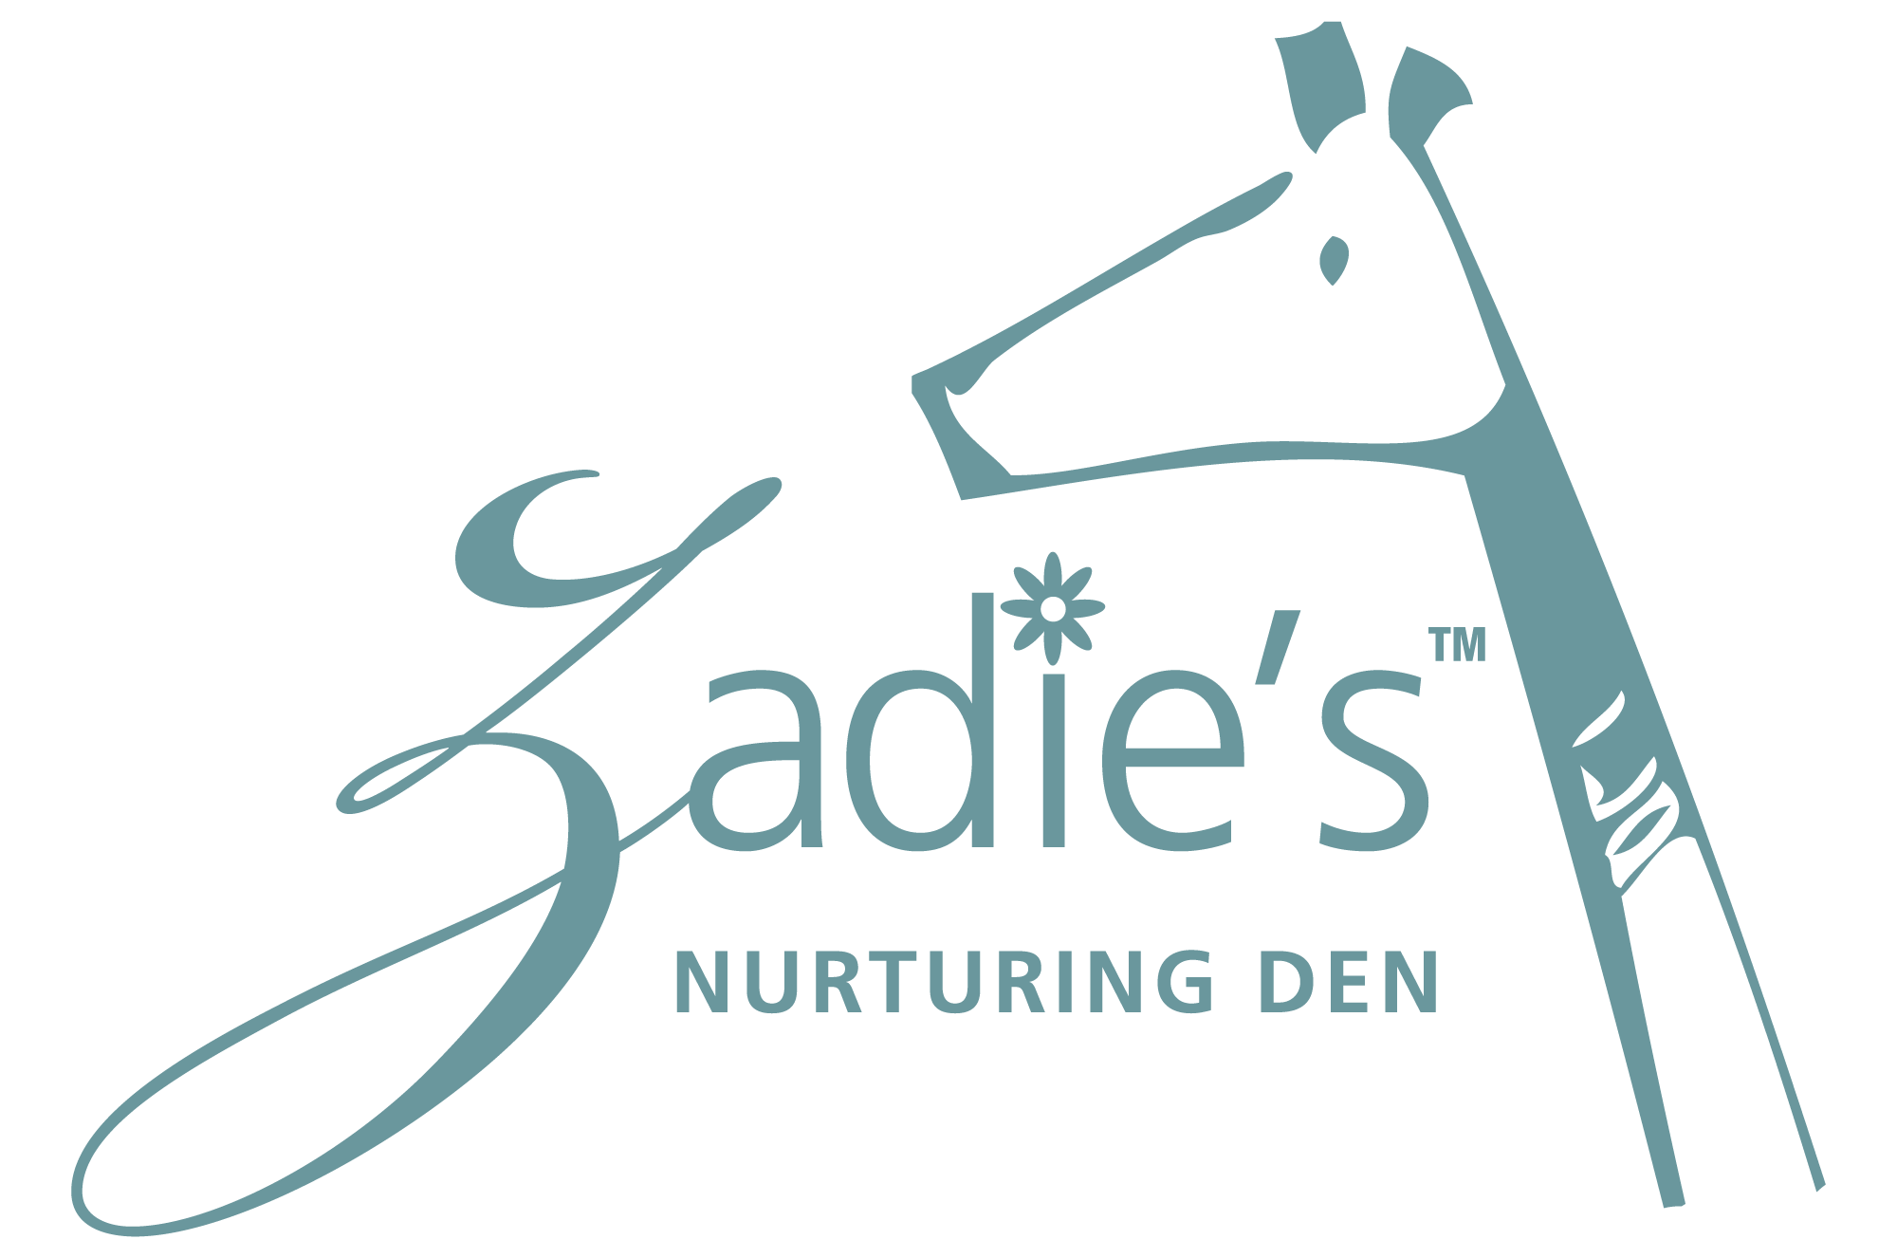

CHILD’S NAME: _________________________________________ | BIRTHDATE: _______________________________
CONTRACT PERIOD: _____________________________________ | ENROLLMENT DATE: ________________________

FEES
There is a $____________ non-refundable enrollment fee per child for all first time enrollees, payable with your completed enrollment forms. Your monthly tuition fee of $____________ is to be paid in advance by the 7th of every month. Payments received after the 7th will incur a late payment fee of $50.00 per week until your account is paid in full.

Failure to pay your tuition or any other charges when due gives Zadie’s™ the right to certain remedies such as immediate termination of child care services.

Your security deposit of $____________ will be applied to your last month at Zadie’s™ if the proper written notice of one full month prior to your departure is provided. Notice must be received the last day of the month to ensure a whole month’s notice is received.

Zadie’sTM Nurturing Den’s main operating hours are from 7 am – 7pm, Monday thru Friday. Morning care starting at 6:30am is available for an additional $__________/week with a minimum commitment of four weeks. The fee for early drop off or late pick up is $_________ per child, per hour or any part of the hour. These charges will be posted to your account for any day you drop off early or pick up late.

The fee for returned checks is $____________. After two returned checks, only cash or money orders will be accepted. Any payments given for tuition will be processed based on our internal processing schedule. Posted dated checks are not acceptable.

PLEASE NOTE: There will be no adjustments to your tuition for any reason. This includes natural disasters, vacations, illness, summer breaks, etc. For extreme cases, any request for tuition credit must be put in writing and sent to the attention of the on-site director for consideration.

Signature: __________________________________________________

SNOW DAYS / EMERGENCY CLOSINGS / OTHER CLOSINGS
While every effort will be made to be open, for the safety of our staff, parents, and children during inclement weather, or if there is an unforeseen emergency including but not limited to natural disasters, Zadie’s™ will be closed at the discretion of the Agency/Executive Director. Please call Zadie’sTM for a recorded message after 6am, log onto the website or community site for updates or any other pertinent information. Any parent dropping off before we open (in the event of a delayed opening) will be charged the current early drop off rate. In the event of an early closing, any parent picking up after the requested pick-up time will be charged a late pick up fee.

Signature: ____________________________________________________

FAMILY VACATIONS
Please provide written notice when you plan to take vacation. You are expected to pay your regular tuition and pre-payment of tuition must be made prior to your vacation if your tuition date is due while away.

Signature: ____________________________________________________

IN-HOUSE TRAINING
Two or three times per year we will conduct in-house training for our staff. On those days the center will be closed or close early.
On-going staff training is necessary so that we can provide the best possible care for your child. Staff training is usually conducted the Thursday and Friday before Labor Day.
Signature __________________________________________________

HOLIDAYS
Zadie’sTM is closed for the following holidays with full tuition required:

For holidays that fall on Saturday and Sunday, the center will be closed that Friday or Monday, respectively.

- Columbus Day
- Christmas Eve thru New Year’s Day
- Dr. King’s Birthday
- Independence Day
- Good Friday
- Labor Day
- Memorial Day
- President’s Day
- Thanksgiving (Wed 3pm, Thu & Fri )
- Veteran’s Day (at 5pm)

Signature: __________________________________________________

BIRTHDAY CELEBRATIONS
If your child is celebrating his/her birthday at Zadie’sTM we ask parents for a contribution of a hard cover book or commercial strength puzzle to be donated to their child’s classroom in lieu of a party rental fee (suggested retail price $25.00 or more).

Signature: _______________________________________

HEALTH / ILLNESS
To protect your child and the health of all staff and children, we reserve the right to determine when a child is too ill to be cared for at Zadie’s™. During these occasions, you may be asked to keep your child home or to pick up early.
We must have written permission before administering any medication. The medication should be in its original container, with the child’s name and current date. Also, please inform us of any known allergies your child has to food or medicine. Any student with a known food/drug allergy, asthma or seizures must submit a medical action plan signed by their child’s physician upon enrollment and at the beginning of every new contract cycle.
Signature: __________________________________________________

ENRICHMENT ACTIVITIES
Zadie’sTM allows outside vendors to enhance the lives of our students by providing a variety of enrichment activities and private tutoring. However, if your child’s account does not have a zero (0) balance you will not be able to enroll in extra activities held at Zadie’sTM. All class lists will be reviewed by the accountant before the first day of activities.

Signature: __________________________________________________

OUTSIDE BABYSITTING BY EMPLOYEES
Please note that Zadie’sTM employees are not allowed to provide outside babysitting for any families enrolled at Zadie’sTM.

Signature: ____________________________________________________

MEALS
Zadie’sTM provides a monthly menu that is subject to change without notice. We provide breakfast, lunch, and an afternoon snack for all children.
Signature: ________________________________________________

TERMINATION OF SERVICES
A 30-day written notice of a full month prior to your departure from Zadie’sTM Nurturing Den is required. Notice must be received by the last day of the month to ensure a whole month’s notice is received. If the last day of the month falls on a Saturday or Sunday, notice must be received by the Friday before the month ends.

Please note that deposits are not refunded but applied to your last month at Zadie’sTM when proper notice is received. Failure to provide proper notice will result in the loss of your security deposit.

Signature: _____________________________________________________

TERMS OF THIS CONTRACT
This contract is valid until ________________________________________________________.

After this date, either party may terminate services or sign a new contract for another year. The fee for contract renewal is $______________. If your termination date occurs after the date listed above, you will be required to pay all fees associated with the renewal process.

This contract can be terminated by either party if the terms of the Termination of Services agreement listed above are not adhered to accordingly.
Parents agree to pay all costs, expenses and fees incurred by Zadie’s™ in enforcing this contract, including but not limited to, collection expenses, court cost, and attorney’s fees. Signing below indicates that you have read and fully understand the terms of this contract.
Any parent financially responsible MUST sign this contract.
I (We) have read and understand the terms and conditions of this contract and agree to abide by all policies as stated.
PARENT’S SIGNATURE: ___________________________________________ | DATE: ____________________________
PARENT’S SIGNATURE: ___________________________________________ | DATE: ____________________________

